Designing Microservices using Spring Boot, Spring Cloud, Eureka and Zuul

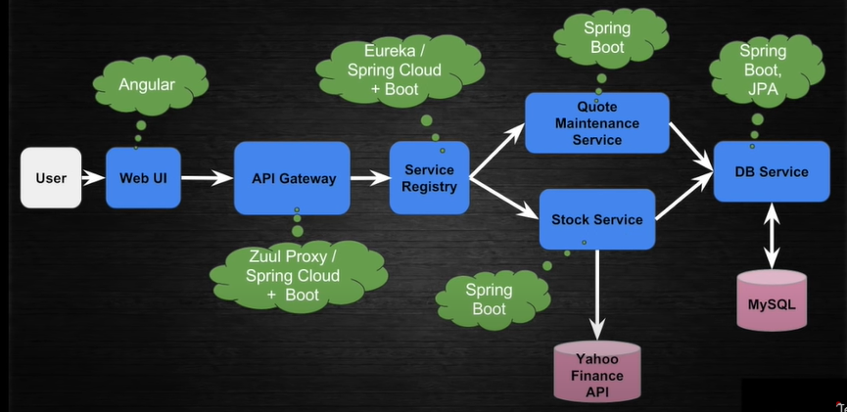

Step 1: Create db-service: add/get by a quote

Spring JPA, MySQL Connector, Spring Web (Embed Tomcat)

application.properity.xml

#configure spring.application.name=db-service

#server.port=8300

#configure the properties of DB

Step 2: Create stock-service: get info of given quote.

1. Pom.xml

#Spring Web && Eureka Discovery &&Yahoo.Finiacial.API

@EnableEurekaClient

@SpringBootApplication

3.

application.yml

eureka:

client:

registerWithEureka: True

fetchRegistry: True

serviceUrl:

defaultZone:http://localhost:8302/eureka

instance:

hostname:localhost

1. Write a config class

@LoadBalance load the client of Eureka

@Bean

Class RestTemplate {  
}

Step 3: Create Service Registry with Eureka Server

#Spring Web &&Eureka Server

@EnableEurekaServer

@SpringApplication

application.yml

spring:

application:

name: euraka-service

server

port: 8302

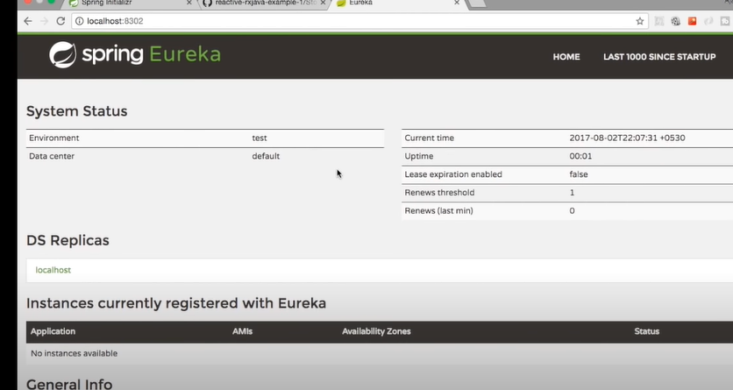

Step 4: API GateWay with Zuul Proxy

@EnableZuulProxy

@EnableEurekaServer

@SpringBootApplication

Public class EurekaServiceApplication

Zuul:

#Service will be mapped under the /api url

